**Module (Bootstrap Basic & Advanced) – 6**

1. **What are the advantages of Bootstrap?**

**Ans.**Bootstrap is a popular open-source front-end framework that facilitates the development of responsive and mobile-first websites. It offers a variety of advantages,Here are some of the key advantages:

* Responsive Design
* Pre-designed Components
* Consistency
* Grid System
* Pre-styled Components
* Customization
* Mobile-First Approach
* Time-Saving
* Cross-browser Compatibility
* Open Source and Free

Bootstrap is a versatile and powerful framework that offers a range of features to streamline the web development process.While Bootstrap offers many advantages, it's important to consider the specific needs of our project and whether a particular framework aligns with our development goals and preferences.

1. **What is a Bootstrap Container, and how does it work?**

**Ans.**In Bootstrap, a container is a fundamental layout element that helps to organize and structure the content within a web page. It is part of the grid system and plays a crucial role in creating responsive and consistent layouts. Bootstrap provides different types of containers, namely .container and .container-fluid.When you use containers, especially in conjunction with the grid system, Bootstrap helps in creating responsive layouts. The grid system divides the container into a 12-column layout, and you can use classes such as .col-sm-, .col-md-, and so on, to define how many columns a particular element should span based on different screen sizes.

* **container**: This is a fixed-width container. It means that the width of the container remains constant, regardless of the screen size. The width of the container is set based on certain breakpoints, ensuring that the content is centered and well-proportioned.
* **container-fluid:** This is a full-width container that spans the entire width of the viewport. It is responsive and adjusts its width according to the screen size, making it suitable for creating full-width sections.

1. **What are the default Bootstrap text settings?**

**Ans. Here are some of the default Bootstrap text-related classes:**

* **.text-left**
* **.text-center**
* **.text-right**
* **.text-justify**
* **.text-nowrap**
* **.text-lowercase**
* **.text-uppercase**
* **.text-capitalize**
* **.font-weight-bold**
* **.font-italic**

These classes can be applied to various HTML elements, such as <p>, <span>, <h1>, <h2>, etc. You can use these classes individually or combine them based on your specific styling needs. Additionally, Bootstrap provides responsive text classes like .text-sm, .text-md, and .text-lg to control text size on different screen sizes.

1. **What do you know about the Bootstrap Grid System?**

**Ans.** The Bootstrap Grid System is a responsive, mobile-first grid system that facilitates the creation of responsive layouts in web design. The grid system divides the page into a series of rows and columns, making it easy to structure and align content on different devices and screen sizes.

The Bootstrap Grid System provides a flexible and efficient way to create responsive and visually appealing layouts.

* **12-Column Layout**: The grid system in Bootstrap is based on a 12-column layout. Each row in the grid is divided into 12 equal-width columns.
* **Responsive Design:** The grid system is inherently designed to be responsive. It uses a mobile-first approach, meaning that the default styles are targeted towards smaller screens, and styles are then enhanced for larger screens using media queries.
* **Container Classes:** The grid is typically wrapped in a container class to provide a consistent width and center the content.
* **Column Classes**: To define the width of elements within a row, you use column classes such as .col-, .col-sm-, .col-md-, .col-lg-, and .col-xl-.
* **Offset Classes:** Bootstrap also provides offset classes such as .offset-, .offset-sm-, .offset-md-, etc.,
* **Nesting:** You can nest rows and columns within other columns to create more complex layouts.

1. **What is the difference between Bootstrap 4 and Bootstrap 5.**

**Ans.**

It's important to note that while Bootstrap 5 introduces several changes and improvements, upgrading from Bootstrap 4 to Bootstrap 5 may require adjustments in your code due to the removal of jQuery and other changes.

* **jQuery Dependency:**

**Bootstrap 4:** Bootstrap 4 relies on jQuery for some of its JavaScript components.

**Bootstrap 5:** Bootstrap 5 has removed the jQuery dependency. It has been rewritten to use vanilla JavaScript, making it more lightweight and modern.

* **Utility Classes:**

**Bootstrap 4:** Bootstrap 4 primarily uses utility classes for spacing, typography, and other styles.

**Bootstrap 5:** Bootstrap 5 has enhanced and expanded its utility classes for more flexibility and utility.

* **New Features in Bootstrap 5:**

Bootstrap 5 introduces new components and features, such as a floating label form, off-canvas navigation, improved documentation, utility API, and more.

* **Dropped Features:**

Bootstrap 5 has removed some components and features that were present in Bootstrap 4. For example, the card decks, card groups, and input group addons are no longer part of the default package.

* **Improved Grid System:**

Bootstrap 5 has made some improvements to the grid system, providing a more streamlined and consistent approach.

1. **What is a Button Group, and what is the class for a basic Button Group?**

**Ans.**The basic class for a Button Group in Bootstrap is the .btn-group class. This class is applied to a container element that wraps a group of buttons.

<div class="btn-group" role="group" aria-label="Basic example">

<button type="button" class="btn btn-primary">Button 1</button>

<button type="button" class="btn btn-secondary">Button 2</button>

<button type="button" class="btn btn-success">Button 3</button>

</div>

In this example The <div> element has the class btn-group, indicating that it is a button group.Each <button> element inside the group has the class btn to style it as a Bootstrap button.

**Sizing:**

We can use classes like btn-group-lg, btn-group-sm, or btn-group-xs.

**Vertical Button Group:**

You can create a vertical button group by adding the class btn-group-vertical.

**Toolbar:**

Multiple button groups can be combined to create a button toolbar. Wrap the button groups in a <div> with the class btn-toolbar.

1. **How can you use Bootstrap to make thumbnails?**

**Ans.** In Bootstrap, thumbnails are a way to showcase images or content in a visually appealing grid. Thumbnails are often used for creating image galleries or displaying a collection of related content. Bootstrap provides the .thumbnail class to style elements as thumbnails.

1. **In Bootstrap 4, what is flexbox?**

**Ans.**Flexbox provides a more efficient way to arrange, align, and distribute space among items in a container, even when their size is unknown or dynamic.

**Flex Container:**

A container with display: flex or display: inline-flex.

**Flex Items:**

Flex items can be horizontally or vertically aligned within the flex container.The children of a flex container become flex items.

**Flexbox Properties:**

* **Justify Content:**Space between and around content items along the main axis.
* **Align Items:**Defines how the browser aligns items along the cross axis.
* **Flex Direction:**Defines the direction of the main axis.
* **Order:**Controls the order in which the flex items appear in the flex container.
* **Flex:**A shorthand for setting the flex-grow, flex-shrink, and flex-basis properties.

1. **How can one create an alert in Bootstrap?**

**Ans.** In Bootstrap, we can create alerts using the built-in alert component.

**Input:**

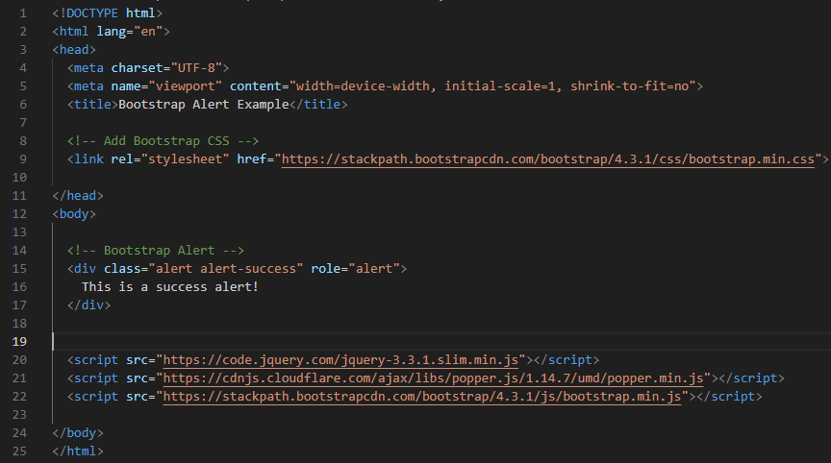

**Output:**

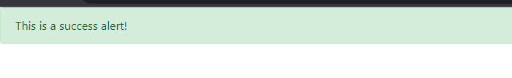

In this example The <div> element with the class alert and alert-success is used to create a success alert. We can replace alert-success with other classes like alert-info, alert-warning, or alert-danger to change the alert's appearance and color.

1. **What is a bootstrap card and how would you create one?**

**Ans.**

**Id Card task link:** <https://github.com/Kp9056/bootstrap-assignment-task>



* The <div> element with the class card is used to create the basic card container.
* Inside the card, there is an <img> element with the class card-img-top for the card image.
* The <div> with the class card-body contains the main content of the card, including a <h5> for the card title, a <p> for the card text, and a <a> with the class btn btn-primary for a button.